**DEPARTMENT OF INFORMATION AND COMMUNICATION TECHNOLOGY**

**ISLAMIC UNIVERSITY, BANGLADESH**



**ICT-3104: Electronic Communication and Microwave Engineering Laboratory**

**SUBMITTED TO:**

**Prof. Dr Md. Sipon Miah**

**Professor**

**Information & Communication Technology**

**Islamic University, Bangladesh**

**SUBMITTED BY:**

**Sadia Afrin Kumu**

Roll: 2018056

Reg. No: 1331

Session: 2020-2021

**Experiment No: 01**

**Name of The Experiment:** To Observe Amplitude Modulation and Calculate Modulation Index.

**Objectives:**

1.To understand the concept of amplitude modulation (AM) and its practical application.

2.To observe the modulation process by generating and visualize an AM signal in MATLAB.

3.To understand the concept of Modulation Index.

**Theory:**

Amplitude modulation (AM) is a modulation technique where the amplitude of a carrier wave is varied in proportion to the instantaneous amplitude of a modulating signal (message signal). This process is widely used in radio broadcasting and communication systems.

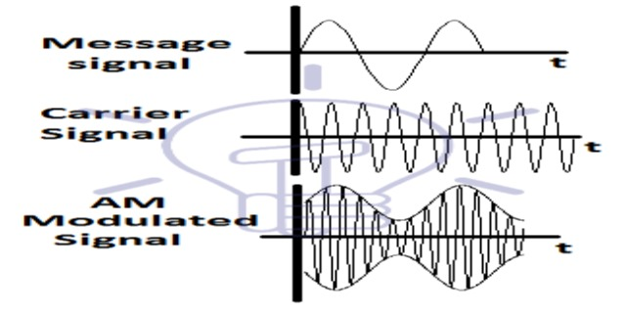

**Key Terms:**

1. **Carrier Signal (C):** A high-frequency sinusoidal wave represented as: where is the amplitude and is the frequency.

2. **Modulating Signal (M):** A lower frequency message signal represented as: where is the amplitude and is the frequency.

3. **AM Signal (S):** The modulated signal expressed as: **s(t)=[Ac+Amcos(2πfmt)]*cos(2πfct)**

**Modulation Index ():**

The modulation index indicates the degree of modulation and is given by:

• 0<m<1: Under-modulated

• m=1: Perfectly modulated

• m>1: Over-modulated, leading to distortion.

**Equation**:

The modulated signal can be expressed as: **s(t)=[Ac+Amcos(2πfmt)]*cos(2πfct)**

Modulation index can be expressed as: **μ=Am/Ac**

**Required Tools: MATLAB** software.

**Source Code:**

%Code for Amplitude Modulation..

clc;

close all;

clear all;

%input the values

Am = input('Enter message signal amplitude: ');

Ac = input('Enter carrier signal amplitude: ');

fm = input('Enter Message frequency: '); %fm<fc

fc = input('Enter Carrier frequency: ');

m = Am/Ac; %input('Enter modulation index'); %m <= 1

t = 0:0.001:1;

%Equation of the message signal

y1 = Am*sin(2*pi*fm*t);

subplot(3,1,1);

plot(t,y1,'blue','LineWidth',1);

xlabel('Time');

ylabel('Amplitude');

title('Message signal','color','red');

%Equation of carrier signal

y2 = Ac*sin(2*pi*fc*t);

subplot(3,1,2);

plot(t,y2,'green','LineWidth',1);

xlabel('Time');

ylabel('Amplitude');

title('Carrier signal','color','blue');

%instantaneous voltage of resulting am wave is..

y = Ac*(1+m*sin(2*pi*fm*t)).*sin(2*pi*fc*t);

subplot(3,1,3);

plot(t,y,'red','LineWidth',1);

xlabel('Time');

ylabel('Amplitude');

title('Modulated signal','LineWidth',1);

fprintf('Mudulation index: %.2f',m);

%input 2 4 5 100

**Output:**

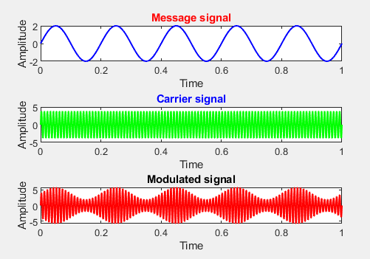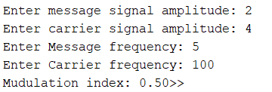

**Result and Discussion:**

1. **Result**:

o The observed AM waveforms confirm the modulation process, displaying the expected envelope corresponding to the modulating signal.

o Calculated modulation index values demonstrate the relationship between the carrier and modulating signals.

2. **Discussion**:

o The modulation index values were within acceptable ranges, indicating efficient modulation.

o Over-modulation scenarios, if observed, resulted in waveform distortion.

o Deviations in results could be attributed to equipment limitations or noise.

**Experiment No: 02**

**Name of The Experiment:** To Observe Frequency spectrum of AM Waveforms.

**Objectives**:

• To understand the concept of Amplitude Modulation (AM) and its frequency components.

• To verify the presence of the carrier, upper sideband (USB), and lower sideband (LSB) frequencies in an AM waveform.

**Theory:**

The frequency spectrum of an Amplitude Modulated (AM) wave consists of a central carrier frequency flanked by two sidebands, one on the higher frequency side (upper sideband) and one on the lower frequency side (lower sideband), with the bandwidth of the AM signal being twice the modulating frequency **(B.W. = 2fm).**

**Required Tools:** MATLAB software.

**Source Code:**

%Code for Amplitude Modulation.

clc;

close all;

clear all;

%input the values

Am = input('Enter message signal amplitude: ');

Ac = input('Enter carrier signal amplitude: ');

fm = input('Enter Message frequency: '); %fm<fc

fc = input('Enter Carrier frequency: ');

m = Am/Ac; %input('Enter modulation index'); %m <= 1

t = 0:0.001:1;

%Equation of the message signal

y1 = Am*sin(2*pi*fm*t);

subplot(3,1,1);

plot(t,y1,'blue','LineWidth',1);

xlabel('Time');

ylabel('Amplitude');

title('Message signal','color','red');

%Equation of carrier signal

y2 = Ac*sin(2*pi*fc*t);

subplot(3,1,2);

plot(t,y2,'green','LineWidth',1);

xlabel('Time');

ylabel('Amplitude');

title('Carrier signal','color','blue');

%instantaneous voltage of resulting am wave is..

y = Ac*(1+m*sin(2*pi*fm*t)).*sin(2*pi*fc*t);

subplot(3,1,3);

plot(t,y,'red','LineWidth',1);

xlabel('Time');

ylabel('Amplitude');

title('Modulated signal','LineWidth',1);

fprintf('Mudulation index: %.2f',m);

%input 2 4 5 100

**Output:**



**Result and Discussion:**

The frequency spectrum of the AM waveform showed the presence of the carrier frequency (fcf_c) along with the upper (fc+fmf_c + f_m) and lower sidebands (fc−fmf_c - f_m). The amplitude of the sidebands was proportional to the modulation index (mm). For m≤1m \leq 1, the waveform was clear, while over-modulation (m>1m > 1) caused distortion and spectral spreading. The observed spectrum confirmed the theoretical structure of an AM signal, where the carrier does not carry information but dominates the power. The sidebands carried identical information, emphasizing the potential for bandwidth efficiency improvements through suppressed carrier or single-sideband techniques. A proper modulation index is critical to prevent distortion and ensure signal clarity in AM communication systems.

**Experiment No: 03**

**Name of The Experiment:** To Observe Frequency spectrum of FM Waveforms.

**Objectives:**

• To understand the concept of Frequency Modulation (FM) and its frequency spectrum.

• To observe the frequency spectrum of FM waveforms using a spectrum analyzer.

• To analyze the impact of modulation index and modulating frequency on the spectral components of FM signals.

**Theory:**

The frequency spectrum of an **FM (Frequency Modulation)** wave consists of a central carrier frequency with numerous sidebands spread out on either side, creating a wide band of frequencies due to the varying instantaneous frequency of the carrier based on the modulating signal, unlike AM where the spectrum is more concentrated around the carrier frequency; in practice, FM radio broadcasts typically occupy a bandwidth of around 200 kHz around the carrier frequency within the 88-108 MHz band.

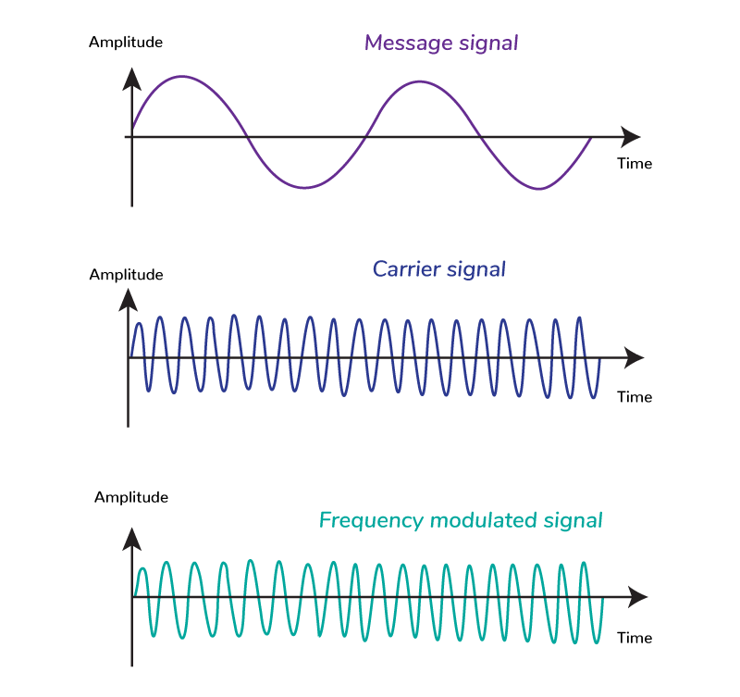

**Equation**: The expression for a frequency modulated wave can be derived from the basic equation for frequency modulation. The general form of an FM wave can be written as ***s(t) = Ac cos(2πfct + 2πkf ∫t 0 m(τ)dτ.***

**Required Tools:** MATLAB software.

**Source Code:**

%input the values

vm = input('Enter message signal Amplitude: ');

vc = input('Enter carrier signal Amplitude: ');

fm = input('Enter Message Frequency: '); %fm<fc

fc = input('Enter Carrier frequency: ');

m = input('Enter modulation index: ');

t = 0:0.001:1;

Fs=1000;

%Equation of the message signal

y1 = vm*cos(2*pi*fm*t);

subplot(4,1,1);

plot(t,y1,'blue','LineWidth',1);

xlabel('Time');

ylabel('Amplitude');

title('Message Signal','color','red');

grid on;

%carrier

y2 = vc*cos(2*pi*fc*t);

subplot(4,1,2);

plot(t,y2,'magenta','LineWidth',1);

xlabel('Time');

ylabel('Amplitude');

title('Carrier Signal','color','blue');

grid on;

%The instantaneous value of FM voltage wave is given by.........

y = vc*cos(2*pi*fc*t+m.*sin(2*pi*fm*t));

subplot(4,1,3);

plot(t,y,'red','LineWidth',1);

xlabel('Time');

ylabel('Amplitude');

title('FM Signal','color','red');

grid on;

%Compute the one sided spectrum using FFT

N = length(y);

FM_spectrum = fft(y)/N;

frequencies = (0:(N/2-1))*Fs/N;

%Plot the FM Spectrum

subplot(4,1,4);

stem(frequencies,abs(FM_spectrum(1:floor(N/2))),'red','LineWidth',1);

axis([0 200 0 1]);

xlabel('Frequency (Hz)');

ylabel('Amplitude');

title('FM Signal Spectrum');

%sample_input 2 4 5 100 10

**Output:**

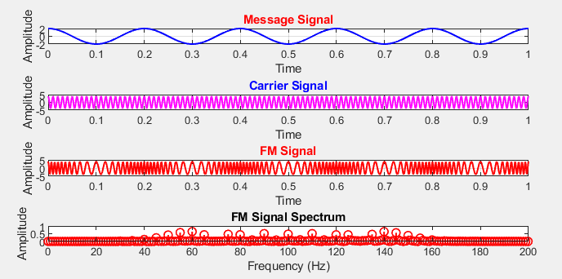

**Result and Discussion:**

The frequency spectrum of the FM waveform displayed a central carrier frequency surrounded by multiple sidebands at integer multiples of the modulating frequency (fc±nfm). The number and amplitude of these sidebands depended on the modulation index ( β). A higher modulation index resulted in increased spectral spreading, consistent with Carson's Rule for FM bandwidth.

**Experiment No: 04**

**Name of The Experiment:** To Generate **AM** waveforms.

**Objectives:**

1.To understand the concept of amplitude modulation (AM) and its practical application.

2.To observe the modulation process by generating and visualize an AM signal in MATLAB.

**Theory:**

Amplitude modulation (AM) is a modulation technique where the amplitude of a carrier wave is varied in proportion to the instantaneous amplitude of a modulating signal (message signal). This process is widely used in radio broadcasting and communication systems.

**Required Tools:** MATLAB software.

**Source Code:**

%Code for Amplitude Modulation..

clc;

close all;

clear all;

%input the values

Am = input('Enter message signal amplitude: ');

Ac = input('Enter carrier signal amplitude: ');

fm = input('Enter Message frequency: '); %fm<fc

fc = input('Enter Carrier frequency: ');

m = Am/Ac; %input('Enter modulation index'); %m <= 1

t = 0:0.001:1;

%Equation of the message signal

y1 = Am*sin(2*pi*fm*t);

subplot(3,1,1);

plot(t,y1,'blue','LineWidth',1);

xlabel('Time');

ylabel('Amplitude');

title('Message signal','color','red');

%Equation of carrier signal

y2 = Ac*sin(2*pi*fc*t);

subplot(3,1,2);

plot(t,y2,'green','LineWidth',1);

xlabel('Time');

ylabel('Amplitude');

title('Carrier signal','color','blue');

%instantaneous voltage of resulting am wave is..

y = Ac*(1+m*sin(2*pi*fm*t)).*sin(2*pi*fc*t);

subplot(3,1,3);

plot(t,y,'red','LineWidth',1);

xlabel('Time');

ylabel('Amplitude');

title('Modulated signal','LineWidth',1);

%input 2 4 5 100

**Output:**

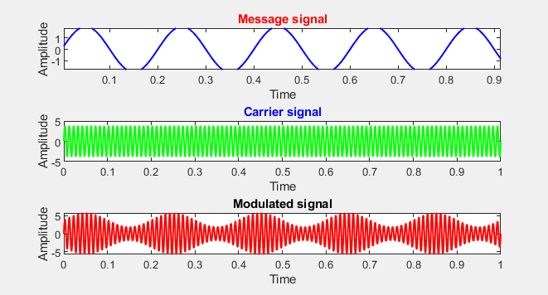

**Result and Discussion:**

The amplitude modulation (AM) waveform was successfully generated in MATLAB, and the modulation index was calculated. The carrier signal, modulating signal, and AM signal were visualized, showing a clear and accurate envelope corresponding to the modulating signal. For a modulation index (mmm) less than 1, the AM signal exhibited proper modulation without distortion, demonstrating effective transmission. The results highlight the importance of maintaining m≤1m \leq 1m≤1 to ensure signal clarity and avoid ov er- modulation, which could lead to envelope distortion and information loss. MATLAB provided an efficient and flexible environment for generating and analyzing the AM waveforms.

**Experiment No: 05**

**Name of The Experiment:** To Generate FM waveforms.

**Objectives:** To generate Frequency Modulation (FM) waveforms using MATLAB and analyze the frequency variations in response to the modulating signal.

**Theory:**

Frequency Modulation (FM) is a modulation technique where the frequency of a high-frequency carrier signal varies in proportion to the amplitude of a low-frequency modulating signal. This technique encodes information by changing the carrier's frequency while keeping its amplitude constant, making FM more resistant to noise compared to Amplitude Modulation (AM). The frequency deviation is directly proportional to the amplitude of the modulating signal, and the modulation index determines the extent of this deviation, calculated as the ratio of frequency deviation to the frequency of the modulating signal. FM is widely used in applications such as FM radio broadcasting, due to its superior noise immunity and ability to transmit high-quality signals.

**Equation**: The frequency modulated wave will be: **fm(t) = fc + k Am. cos (2πfmt)**

**Required Tools:** MATLAB software.

**Source Code:**

%Code for Frequency Modulation....

clc;

close all;

clear all;

%Input the values.....

vm = input('Enter Message signal amplitude = ');

vc = input('Enter Carrier signal Amplitude = ');

fm = input('Enter Message frequency = ');

fc = input('Enter Carrier frequency = ');

m = input('Enter Modulation Index = '); % Modulation index (m)>=1

t = 0:0.001:1; %upto 1000 samples

%Equation of Message Signal...

y1 = vm * cos(2*pi*fm*t);

subplot(3,1,1);

plot(t,y1,'blue','LineWidth',1);

xlabel('Time');

ylabel('Amplitude');

title('Message Signal','color','red');

grid on;

%Equation of Carrier Signal...

y2 = vc*cos(2*pi*fc*t);

subplot(3,1,2);

plot(t,y2,'red','LineWidth',1);

xlabel('Time');

ylabel('Amplitude');

title('Carrier Signal','color','blue');

grid on;

%The instantaneous value of FM voltage wave is given by.........

y = vc*cos(2*pi*fc*t+m.*sin(2*pi*fm*t)); % Equation of Modulated signal

subplot(3,1,3);

plot(t,y,'green','LineWidth',1);

xlabel('Time');

ylabel('Amplitude');

title('FM Signal','color','red');

grid on;

%input 2 4 5 100 10

**Output:**

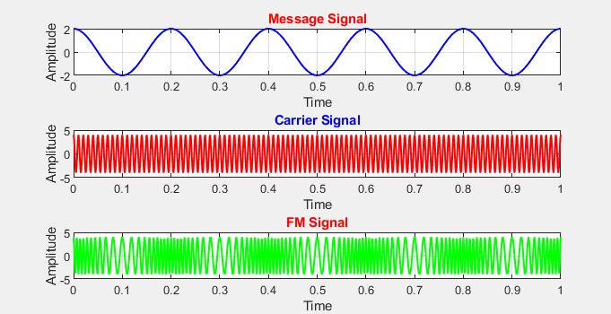

**Result and Discussion:**

The FM waveform was successfully generated using MATLAB, demonstrating a frequency variation proportional to the amplitude of the modulating signal. The carrier frequency deviated with higher modulating signal amplitudes causing greater frequency shifts. The waveform clearly displayed its resilience to amplitude noise, emphasizing FM's advantage over AM in noisy environments. MATLAB provided a clear visualization of the FM signal, enabling effective analysis of frequency deviations and modulation behavior.

**Experiment No: 06**

**Name of the Experiment:** To Extract Information Signal from Modulated Wave Using Diode Detector.

**Objective**:

To study and extract the information signal (message signal) from an amplitude modulated (AM) wave using a diode detector.

**Theory**:

Amplitude modulation (AM) is a modulation technique where the amplitude of the carrier wave is varied in proportion to the information signal. A diode detector is a simple circuit used to demodulate AM signals and retrieve the original information signal. The basic components of a diode detector include a diode, resistor, and capacitor.

The diode rectifies the AM signal, allowing only one polarity to pass, while the capacitor smooths the rectified signal, extracting the envelope corresponding to the original information signal.

**Required Tools:**

• Function generator

• AM signal generator

• Diode detector circuit

• Oscilloscope

• Resistors and capacitors

• Breadboard and connecting wires

**Source Code:**

clc;

close all;

clear all;

% Parameters

fs = 1000;

fc = 100;

duration = 1;

% Sampling frequency (Hz)

% Carrier frequency (Hz)

% Signal duration (seconds)

t = 0:1/fs:duration; % Time vector

% Information signal (message signal)

Am = 1;

% Amplitude of the message signal

fm = 2;

% Frequency of the message signal

message_signal = Am * sin(2*pi*fm*t);

subplot(5, 1, 1);

plot(t, message_signal, 'b');

title('Message Signal');

xlabel('Time (s)');

ylabel('Amplitude');

% Carrier signal

Ac = 2;

% Amplitude of the carrier signal

carrier_signal = Ac * sin(2*pi*fc*t);

subplot(5, 1, 2);

plot(t, carrier_signal, 'b');

title('Carrier Signal');

xlabel('Time (s)');

ylabel('Amplitude');

% Amplitude Modulation (AM)

modulated_wave = (1 + message_signal) .* carrier_signal;

subplot(5, 1, 3);

plot(t, modulated_wave, 'r');

title('Modulated Wave');

xlabel('Time (s)');

ylabel('Amplitude');

% Diode Detector

rectified_signal = abs(modulated_wave); % Rectification

tau = 0.01; % Time constant for the low-pass filter

alpha = fs/(2*pi*tau);

lpf = tf(alpha, [1 alpha]); % Low-pass filter transfer function demodulated_signal = lsim(lpf, rectified_signal, t); % Low-pass filtering subplot(5, 1,4);

plot(t, demodulated_signal, 'g');

title('Envelop Diode Detector');

xlabel('Time (s)');

ylabel('Amplitude');

sgtitle('Information Signal Extraction using Diode Detector');

**Output:**

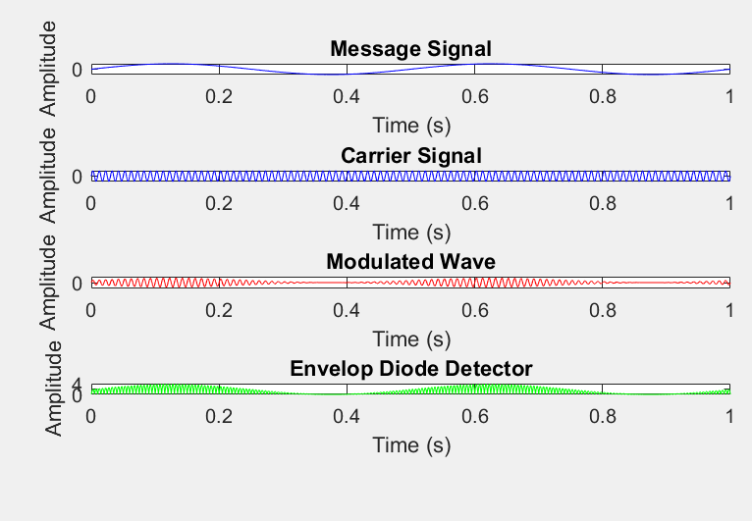

**Procedure:**

1. Set up the circuit on a breadboard as per the provided schematic.

2. Connect the output of the AM signal generator to the input of the diode detector circuit.

3. Use the function generator to generate a low-frequency sinusoidal signal as the modulating signal.

4. Set the carrier signal frequency and amplitude on the AM signal generator.

5. Observe the AM wave using the oscilloscope

**Observations**:

• **AM Signal:** (Describe the amplitude and frequency of the carrier and modulating signals as observed on the oscilloscope.)

• **Detected Signal:** (Note the characteristics of the extracted information signal, such as its frequency and amplitude.)

• **Effect of Component Values:** (Describe how changing the resistor and capacitor values affects the demodulation process.)

**Result & Discussion**:

The diode detector successfully extracted the information signal from the modulated wave. The observed signal matched the original modulating signal in both frequency and amplitude.

**Experiment No: 07**

**Name of the Experiment:** To Study and Understand Pulse Amplitude Modulation (PAM)

**Objective**:

To study and analyze the generation and characteristics of Pulse Amplitude Modulation (PAM) signals.

**Theory:**

Pulse Amplitude Modulation (PAM) is a type of analog modulation in which the amplitude of a series of pulses is varied in accordance with the amplitude of the analog modulating signal. PAM can be categorized into two types:

1. **Single Polarity PAM:** The pulses have only positive amplitude values.

2. **Double Polarity PAM:** The pulses have both positive and negative amplitude values.

PAM is often used as an intermediate step in digital communication systems, such as in Pulse Code Modulation (PCM).

**Required Tools:**

• Function generator

• PAM modulator circuit

• Oscilloscope

• Breadboard and connecting wires

• Resistors and capacitors

• Power supply

**Source Code**:

%Pulse Amplitude Modulation (Natural PAM)

clc;

close all;

clear all;

%parameters

t = 0:0.01:5;

d = 0:1/5:5;

fm = 1;

%Message signal

x = 5*sin(2*pi*fm*t);

subplot(3,1,1);

plot(t,x,'g','LineWidth',1);

title('Message Signal');

xlabel('Time');

ylabel('Amplitude');

grid on;

%Pulse Carrier

y = pulstran(t,d,'rectpuls',0.1);

subplot(3,1,2);

plot(t,y,'r','LineWidth',1);

title('Pulse Carrier');

xlabel('Time');

ylabel('Amplitude');

grid on;

%PAM output

z = x.*y;

subplot(3,1,3);

plot(t,z,'blue','LineWidth',1);

title('PAM modulation(Natural PAM)');

xlabel('Time');

ylabel('Amplitude');

grid on;

**Output:**

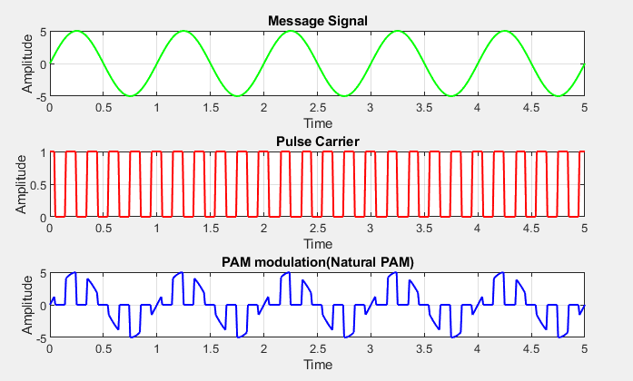

**Procedure**:

1. Set up the PAM modulator circuit on a breadboard as per the provided schematic.

2. Connect the output of the function generator to the input of the modulator circuit to provide the analog modulating signal. 3. Adjust the frequency and amplitude of the modulating signal on the function generator.

4. Power on the modulator circuit and observe the PAM signal on the oscilloscope.

5. Record the PAM signal and note its amplitude and pulse characteristics.

6. Vary the modulating signal parameters (frequency and amplitude) and observe their effects on the PAM signal.

**Observations**:

• **PAM Signal Characteristics:** (Describe the observed pulse amplitudes and their variation with respect to the modulating signal.)

• **Effect of Modulating Signal Frequency:** (Note any changes in the spacing or width of the pulses.)

**Result & Discussion:**

The experiment successfully demonstrated the generation of Pulse Amplitude Modulation signals. The amplitude of the pulses was observed to vary in accordance with the amplitude of the modulating signal.

**Experiment No: 08**

**Name of the Experiment:** To Study **Amplitude Shift Keying (ASK)**.

**Objective:** To understand the generation and demodulation of an **Amplitude Shift Keying (ASK)** signal.

**Theory:** Amplitude Shift Keying (ASK) is a digital modulation technique where the amplitude of a carrier wave is varied based on binary data. Binary 1 corresponds to a high amplitude, while Binary 0 corresponds to a low or zero amplitude. The frequency and phase of the carrier remain constant.

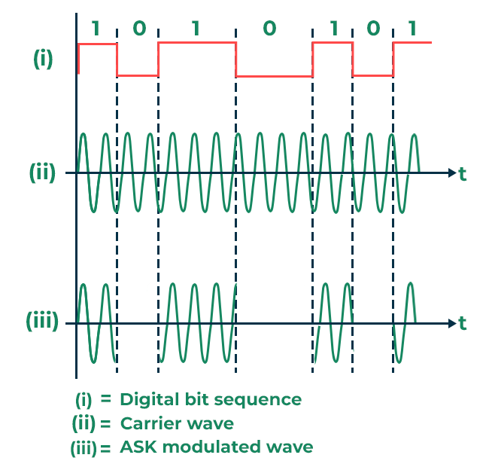

**Required Tools**: **MATLAB**

**Source Code**:

%ASK

clc;

close all;

clear all;

fc=input('Enter the freq of Sine Wave carrier:');

fp=input('Enter the freq of Periodic Binary pulse (Message):');

amp=input('Enter the amplitude (For Carrier & Binary Pulse Message):');

t=0:0.001:1; % For setting the sampling interval

c=amp.*sin(2*pi*fc*t);% For Generating Carrier Sine wave

subplot(3,1,1) %For Plotting The Carrier wave

plot(t,c,'green','Linewidth',1)

xlabel('Time')

ylabel('Amplitude')

title('Carrier Wave')

m=amp/2.*square(2*pi*fp*t)+(amp/2);%For Generating Square wave message

subplot(3,1,2) %For Plotting The Square Binary Pulse (Message)

plot(t,m,'blue','Linewidth',1)

xlabel('Time')

ylabel('Amplitude')

title('Binary Message Pulses')

w=c.*m; % The Shift Keyed Wave

subplot(3,1,3) %For Plotting The Amplitude Shift Keyed Wave

plot(t,w,'red','Linewidth',1)

xlabel('Time')

ylabel('Amplitude')

title('Amplitide Shift Keyed Signal')

%input 100 10 4

**Output**:

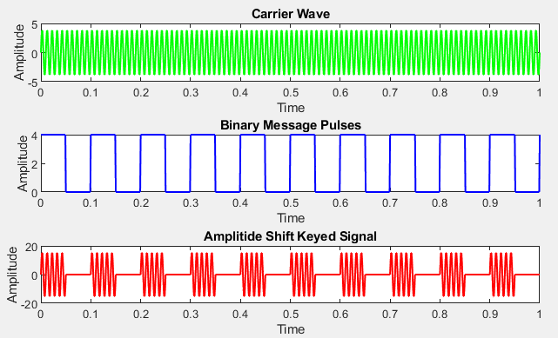

**Result & Discussion:**

1. The amplitude of the carrier changes based on the binary input.

2. The recovered binary signal matches the original input.

**Experiment No: 09**

**Name of the Experiment:** To Study **Frequency Shift Keying (FSK)**

**Objective:** To understand the generation and demodulation of a Frequency Shift Keying (FSK) signal.

**Theory:** Frequency Shift Keying (FSK) is a digital modulation technique where the frequency of the carrier wave is varied based on binary data. Binary 1 is represented by one frequency, while Binary 0 is represented by another frequency. The amplitude and phase of the carrier remain constant.

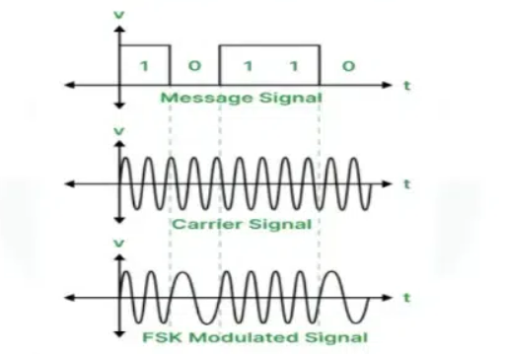

**Tools Required:**

1. Function generator

2. Oscilloscope

3. FSK modulator and demodulator

4. Binary data generator

5. Connecting wires

6. MATLAB

**Source Code**:

%Frequenct Shift Keying...

clc;

close all;

clear all;

fc1=input('Enter the freq of 1st Sine Wave carrier:');

fc2=input('Enter the freq of 2nd Sine Wave carrier:');

fp=input('Enter the freq of Periodic Binary pulse (Message):');

amp=input('Enter the amplitude (For Both Carrier & Binary Pulse Message):');

t=0:0.001:1; % For setting the sampling interval

% For Generating 1st Carrier Sine wave

c1=amp.*sin(2*pi*fc1*t);

% For Generating 2nd Carrier Sine wave

c2=amp.*sin(2*pi*fc2*t);

subplot(4,1,1); %For Plotting The Carrier wave

plot(t,c1,'blue','Linewidth',1);

xlabel('Time');

ylabel('Amplitude');

title('Carrier 1 Wave');

subplot(4,1,2) %For Plotting The Carrier wave

plot(t,c2,'blue','LineWidth',1);

xlabel('Time');

ylabel('Amplitude');

title('Carrier 2 Wave');

%For Generating Square wave message

m=amp/2.*square(2*pi*fp*t)+amp/2;

subplot(4,1,3); %For Plotting The Square Binary Pulse (Message)

plot(t,m,'red','LineWidth',1);

xlabel('Time');

ylabel('Amplitude');

title('Binary Message Pulses');

for i=0:1000 %here we are generating the modulated wave

if m(i+1)==0

mm(i+1)=c2(i+1);

else

mm(i+1)=c1(i+1);

end

end

subplot(4,1,4); %For Plotting The Modulated wave

plot(t,mm,'green','LineWidth',1);

xlabel('Time');

ylabel('Amplitude');

title('Modulated Wave');

%input 10 30 5 4

**Output**:

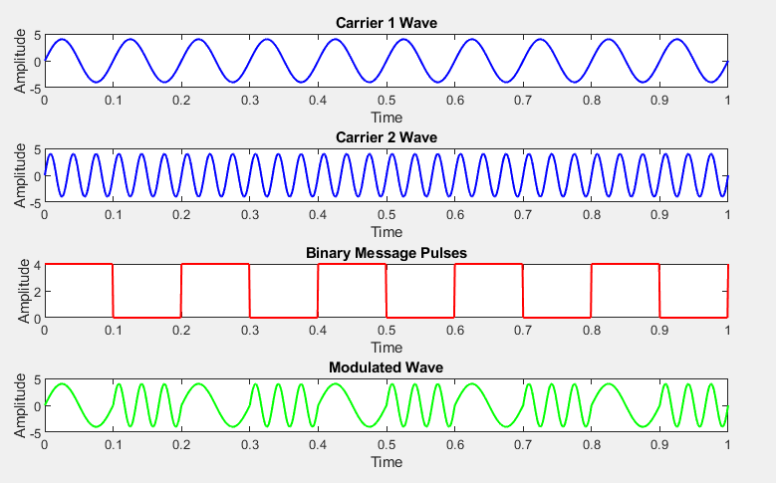

**Observations:**

1. The carrier frequency changes based on the binary input.

2. The recovered binary signal matches the original input.

**Result & Discussion:** FSK modulation and demodulation were successfully implement.